Corner Green - Neighbourhood watch report – September 2025
The Corner Green WhatsApp Neighbourhood Watch group is still going strong and if you haven’t requested access already, feel free to email me directly to get onboard. This year I have had no formal reports of criminal activity in Corner Green bar some recent anti-social behaviour from some youths (thanks to Fiona and Andrew for sorting) and possibly some un-confirmed dogging in the car park. Our watch is part of the Cator Estate Neighbourhood watch (which now has their own ‘outgoing’ WhatsApp group) and we are associated with an informal Span Estate watch and the Greenwich Borough Neighbourhood watch in order to share relevant info. To give you an idea of how much crime has been reported across our ward up to June 2025, please see the data below taken from the www.police.uk website. If you want to get more regular info on Local Policing feel free to visit the brand new www.metengage.co.uk website, and sign up for regular updates.
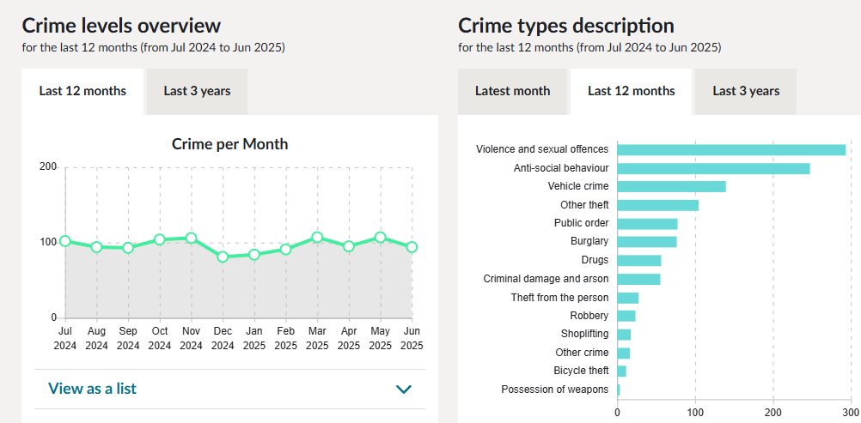
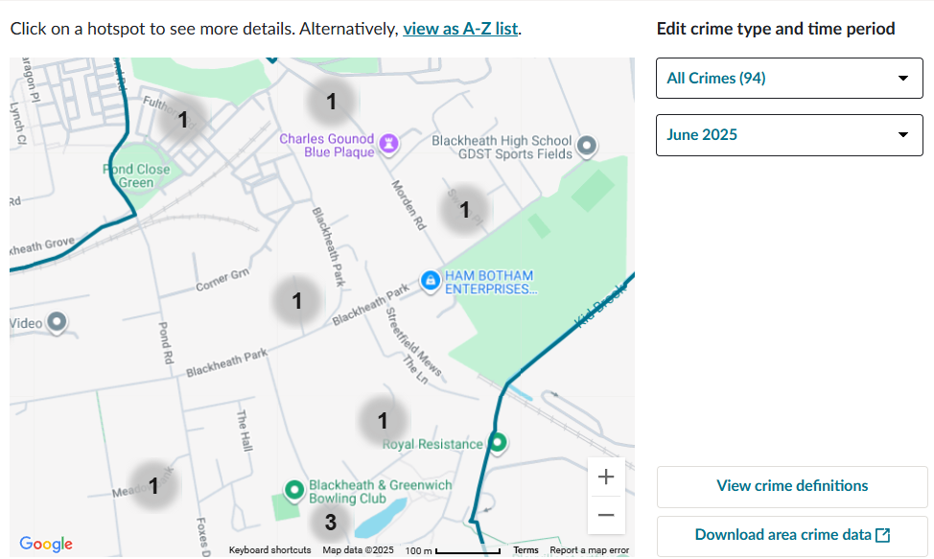
NB Data table is for the Blackheath Westcombe ward, map is magnified towards the Cator Estate, data is based on the whole ward.
As always, if you detect a crime in action phone 999 immediately or if the crime has happened and you want to report it phone 101. Please do let me know in confidence as I’m not necessarily informed by our local Policing Team, although I’ve known our local Constable for over 40 years.
Mark Helm Corner Green Neighbourhood watch co-ordinator (markghelm@gmail.com)

